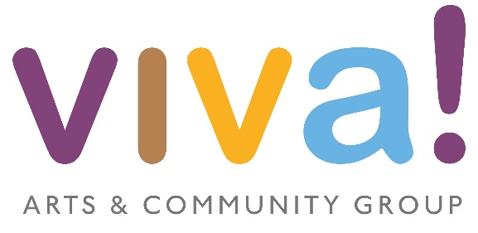

Viva Arts and Community Group
Bursary Application 2023
Deadline for application: 7th June 2023

Name of Viva Member
Name of applicant if different from above
Event / show / trip etc.
Please give dates if known
Contact telephone number
Email Address
Address
How long has the member been involved with Viva?
This will not affect your application
Letter of application
Please state as fully as possible the reasons for the application giving all relevant information

Please send to bev@viva-group.org.uk by the date stated above.

Please note that all information in this document is confidential and will be handled
by a Viva Trustee.

